


The Willows
Little GEM (Grow, Eat, Move) Project

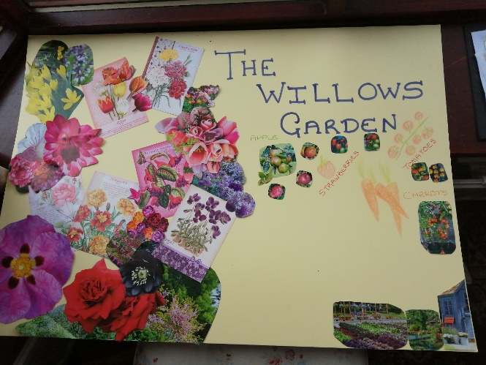


Background
The Little Gem (Grow, Eat, Move) project has been set up to provide a social and horticultural therapy programme for residents and ‘comfort day’ clients at The Willows Dementia Hub and members of the local community.
The aim of the project is to help people to improve their mental health and feelings of wellbeing through providing meaningful activities – some of which take place in the on-site garden area.
These include:
- Table-top gardening
- Growing herbs, fruit and vegetables
- Nature-based craft activities
- Cooking and eating the produce grown on site
- Armchair exercise classes (Link4Life)
- Activities which include the Rempods (bar and seaside)
- The virtual bike
- The large Ipad
For our dementia clients, the activities were designed to reduce the symptoms of their condition which includes feelings of anxiety and agitation, to improve cognitive function and motor skills, sleep and concentration as well as improving speech and communication.
Project evaluation has taken place using observational techniques and anecdotal evidence to measure any reduction in symptoms once clients had taken part in the sessions and to reduce social isolation for residents who have attended from the local community.
To evidence the evaluation we have included case studies in Appendix II which show how two very different people react to the activities. EY is a 50 year old male who is physically very able and needs to have activities to reduce his energy in order to mitigate any agitation. JM is a frail, elderly lady who can tolerate minimal physical exercise but can be very restless and agitated at night.
Implementation of Activities
Get up and Grow
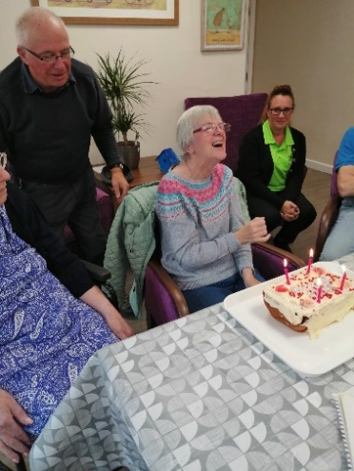
Get up and Grow’s horticultural programme (see Appendix 1 for the full horticultural therapy programme) is now complete and participants who have been involved in the project have responded positively to the sessions with demand for attendance higher than anticipated.
Family have said how lovely it is to hear their loved ones laugh again and often express surprise when their relative completes a task or have a rare moment where they can talk normally with their loved one as they remember who they are. The weekly sessions have been well attended with an average of between 10 and 16 participants, including both residents and non-residents from the local area.

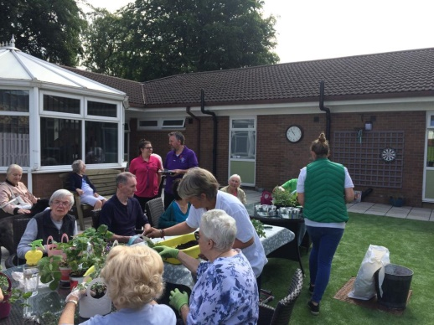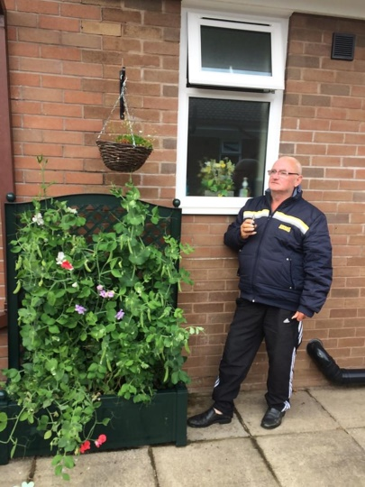
Family members have also attended with day service clients who have participated in the activity, often providing therapeutic benefits to them both.
This has naturally created a Dementia Support Group and is something that could be developed as an additional service to family members and carers in order to support the health and wellbeing of family members during an incredibly challenging time.
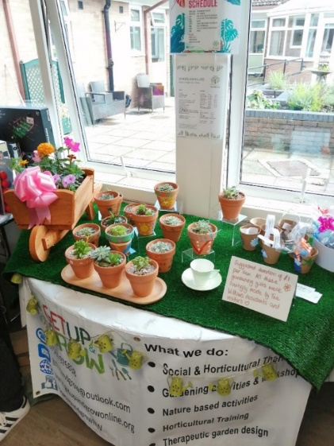
An added benefit of the project has been the selling of products made by the residents.
These have been sold at The Willow’s Summer and Christmas Fairs, helping to create project sustainability and to give attendees a real sense of purpose and achievement through vocational therapy.

Things that have gone well
Attendance has been higher than anticipated due to the growing popularity of the sessions. Members of the local community regularly come along to the weekly sessions - for those people, they feel that they are making a valuable contribution to The Willows and supporting the people who live at the Dementia Hub as well as those who regularly attend ‘comfort days’.
Both the growing sessions and nature-based craft sessions have gone well, particularly flower arranging, bread-making and gel printing. We have tried to include variety in the horticultural programme and new craft activities that perhaps may have initially felt challenging for a person living with dementia. However, the residents and participants have surprised us with their agility to complete a task, shown how focusing on an activity can stimulate speech and conversation – more importantly, how for some people, it can have a calming effect and the ability to ‘bring them back to the present’ – albeit for a brief moment.
The development of the outdoor garden space has demonstrated that change is possible which can offer comfort to those living with dementia.
Implementing a horticultural therapy programme has also helped to secure additional funding for a therapeutic allotment space which can not only be used for sessions but for the local community as well such as local residents and schools. The goal is to regularly grow produce that can be eaten by attendees and used in The Willows café.
A surprising aspect of the sessions was seeing family getting involved – in some cases seeing the sessions as their own bit of self-care – especially the nature based crafts – which provided them with therapeutic benefits and a break from their difficult routine of being a carer. They also talked to each other providing support – this is something that could become a more permanent service.
One difficulty has been the growing food and cooking it on-site, particularly when we started the sessions in the middle of the growing season. However, this is something that we are planning more of once the allotment space is up and running. In the meantime we have designed some sessions around smoothie drinks using some of the herbs (such as mint), more bread making and simple soups during the remaining winter months.
Overall all the horticultural therapy activities encouraged good social contact and easy conversation for everyone who participated, fulfilling the fact that gardening as therapy is accessible to everyone and can be adapted no matter what barriers a person may have.
What we learnt
- It’s important to get to know clients and provide them with a range of activities in order to match interests and physical capabilities. Knowing the participants makes it easier to plan effectively. We now know to ask the staff about medical background and for this information to be shared before the sessions start. Going forward, it might be useful to share details of our sessions a few days before they take place so that staff know who would be most suitable to participate.

- There were limitations of space for wheelchairs and for the facilitators to manoeuvre around clients. Get up and Grow reviewed seating plans to try and make it easier in the future.

- In order to fulfil risk assessments when working with compost, there is a need to put on protective gloves. This can often take up about 10 minutes of the session as some attendees struggle with completing the task of putting on clothing. We notified staff beforehand that this was required and staff also helped by putting protective clothing on the residents before the session began.

- Attendees found it difficult when working outside when the weather was hot. Shade was provided for all clients and thought needed to be given to skin protection and dehydration. Working together with the staff at The Willows ensured that this was provided when the warm weather returned.

- The equal importance of not just completing the task but also to ask questions during the session in order to stimulate memory, trigger reminiscing and just taking the time to have a chat and ask participants how they are doing.

- Our planned evaluation using the Leuven Scale – which observes facial expression at the beginning and end of each session – was difficult to complete due to the fact that there were between 10 and 16 participants and only 2 Horticultural Therapists.

Rempods

The Willows purchased two Rempods (Remembrance Pods), a traditional bar with bar tables and chairs and a seaside package which included deckchairs. The Rempod packages also included nostalgic soundscapes relevant to the backdrops, ie, the pub Rempod has traditional/war time music (Vera Lynn) and the seaside Rempod has the sound of the sea and this made for a more immersive experience for the residents.



The Bar The Seaside
During the Summer months the Rempods were used in the residents’ garden to create ‘days out’. We arranged for the ice cream van to come and serve ice creams and the residents ate them in the beach Rempod. The pub Rempod has been used both inside and outside and residents queued up to order their own drinks. The feeling of having had a day out raises mood and inspires a party atmosphere. We found this relaxed our residents, reduced agitation and encouraged a more restful sleep.

Link4Life Armchair Exercise Programme
Link4Life attended The Willows once a week for half an hour for our comfort day users and the community and half an hour for our residents. They used music and accessible exercise at differing levels suitable to the service user’s abilities. They enjoyed the chance to dance and exercise which raised their mood and reduced agitation in those that took part. The exercise also helped to settle the residents at night, encouraging a good nights’ rest. See the case studies in Appdendix II for evidence of how our residents’ moods have been influenced by their various activities.

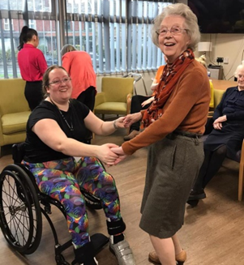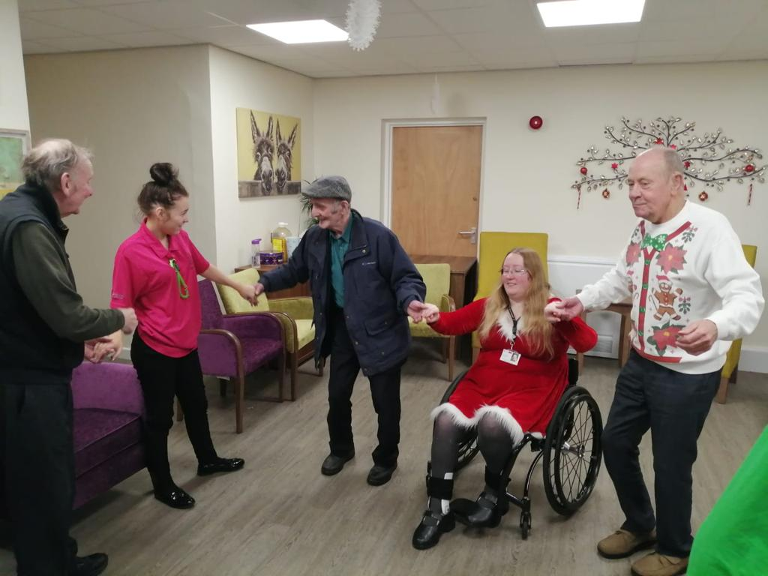

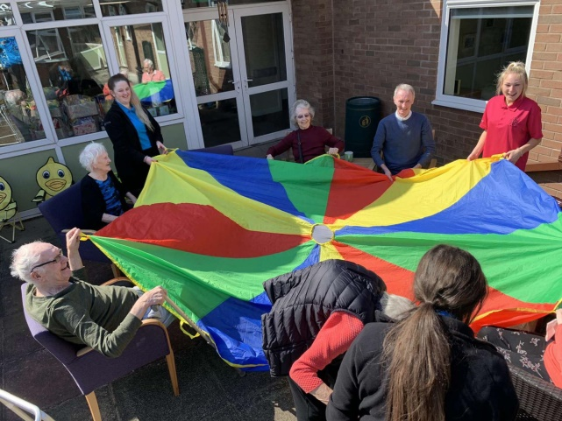

Above and Beyond
The Willows has been inspired to expand on the success of the Little GEM project by purchasing a virtual bike which allows the residents and comfort day users to ‘cycle’ through local scenery without leaving the comfort of their home. This has encouraged physical exercise which has reduced agitation and encouraged a restful sleep.

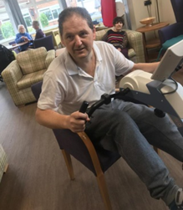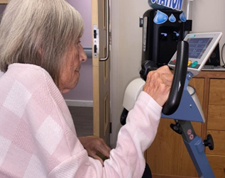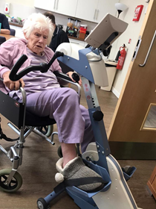

Conclusion

The Willows Little GEM project is providing a varied social, therapeutic and vocational horticultural, active experience for both residents and non-residents attending the Dementia Hub.

The horticultural and exercise sessions offer a safe and social space for residents/non-residents and families to engage in gardening and nature-based activities, ‘days out’ in the pub and at the seaside, and physical activity, helping to promote mental health and wellbeing and encouraging social connections.

This has helped to showcase The Willows as a centre of excellence and demonstrates the change that can happen when residents and members of the community come together.

The programmes also offer a timely opportunity to explore the interest in and potential of Social and Therapeutic Horticulture (STH) for The Willows’ residents. The learning from this can inform the development of the allotment design and usage which could also be opened up to GP social prescribing referrals.

If there is a desire for the new garden to offer a high quality STH experience, then planning and thought will need to be given to how the space is best utilised building on the lessons learnt from this project.

The Willows plans to continue and expand on the aims of the Little GEM programme in the future.

Appendix 1 – Detailed Horticultural Therapy Programme for The Willows Dementia Hub
Activity | Purpose of activity | Review of activity | Observational comments
Painting bird boxes  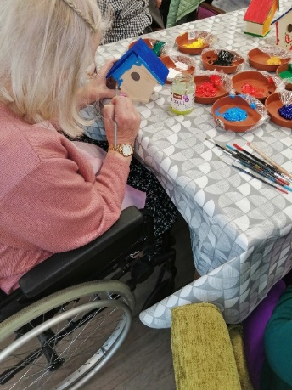 | Increased confidence, self-esteem and concentration  Being able to listen to instructions  Team working and communication  Working under own initiative  Improved motor sensory co-ordination (encouraging good motor skills when dipping paintbrush in paint and applying to the bird box)  Sense of achievement and recognising own improvements  Exploring creativity | Good activity for residents with limited verbal communication.  Allows a freedom of creativity – no real processes to follow. | Residents really enjoyed this activity and even asked if there were more bird boxes to paint.  The skills of people with dementia, particularly artistic skills, are often very surprising when these activities are delivered.  We felt it was an excellent way for clients to express themselves, especially those who have difficulty communicating verbally.  It also allowed us to identify those clients who enjoyed painting who had previously not engaged in some sessions.
Planting strawberries  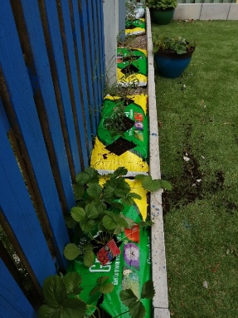 | Increased confidence, self-esteem and concentration  Being able to listen to instructions  Sequencing (making hole in bag, removing compost etc)  Team working and communication  Appreciation of the outdoors, increased motivation and enthusiasm  Numeracy and literacy – counting plants, reading instructions where possible  Memory stimulation/reminiscence therapy  Improved motor sensory co-ordination  Sense of achievement and recognising own improvements | An easy planting exercise that allows residents to enjoy the outdoors.  Questions to stimulate reminiscence – eg did you eat/pick strawberries as a child/with your family which helps to stimulate memory.
Flower arranging   | Team working and communication  Appreciation of the outdoors, increased motivation and enthusiasm  Working under own initiative  Improved memory  Improved motor sensory co-ordination  Exploring creativity | A simple but effective activity which stimulated lots of social activity and laughter.  We were also able to do this session outdoors. | Residents and family talked about growing flowers when they were younger, and people discussed their favourite flowers and colours.  It was particularly nice for residents to be able to give a flower arrangement or a beautifully wrapped posy, made by residents and attendees, to a loved one.
Planting vegetables, herb plants and seeds, onions and garlic in raised trugs  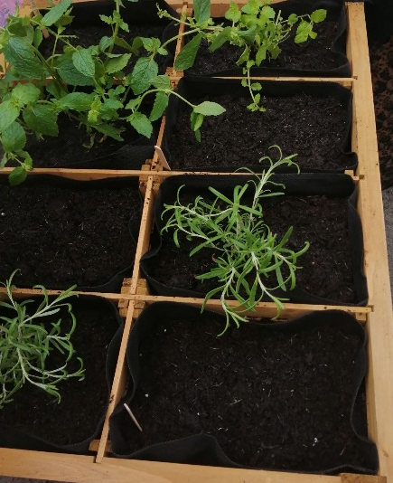 | Improved physical stamina for those more able  Increased confidence, self-esteem and concentration  Being able to listen to instructions  Sequencing  Team working and communication  Appreciation of the outdoors, increased motivation and enthusiasm  Working under own initiative  Numeracy and literacy (counting seeds)  Improved motor sensory co-ordination (fine motor skills for planting seeds, placing plants in sections)  Sense of achievement and recognising own improvements | A big part of the Little ‘GEM’ project is for residents and members of the local community, to grow their own herbs and vegetables.  We started with basic gardening, showing / reminding residents how to plant seeds, vegetable plugs, potatoes etc and then demonstrating how to care for them (watering, weeding etc) | These sessions ran over a few weeks and attendees really enjoyed these workshops, particularly as it was outdoors and on a warm day (residents often complained about being cold, even in warm temperatures).  Herbs were passed around to stimulate memory with familiar smells such as mint, sage and rosemary which would’ve been common when they were younger. Less familiar herbs such as basil and coriander were more difficult to recognise.
Planting seasonal pots  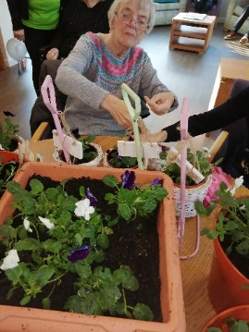  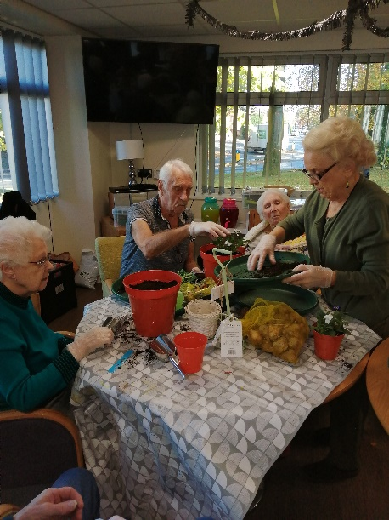 | Improved strength (need to stand, put in compost)  Being able to listen to instructions  Sequencing  Team working and communication  Appreciation of the outdoors, increased motivation and enthusiasm  Working under own initiative  Numeracy and literacy (counting spring bulbs out)  Improved memory  Improved motor sensory co-ordination  Sense of achievement and recognising own improvements | A good activity for residents who had been previous gardeners.  Helps to stimulate memory and cognitive function. | Despite struggling to communicate verbally, some residents knew instinctively what to do, immediately picking up a trowel and placing compost in the pots.  However, there was a lack of sequencing in some people which is something that could be worked on in the future.  Additional observations included residents wanting to tell us how to do it, whilst some showed no interest.
Harvest herbs to make mint tea and bread  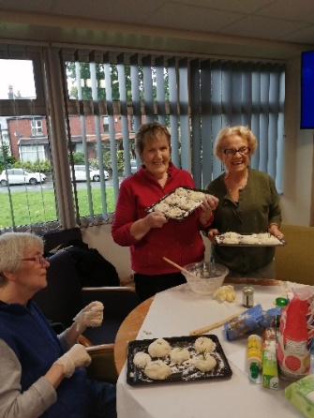 | Increased confidence, self-esteem and concentration  Being able to listen to instructions  Sequencing  Team working and communication  Taste of fresh bread triggers memory  Working under own initiative  Numeracy and literacy (measuring out ingredients)  Improved motor sensory co-ordination  Sense of achievement and recognising own improvements | A really successful activity and one that we will be doing again.  A good activity to stimulate happy memories.  Residents were also able to use the herbs they had grown themselves and eat the bread with their soup! | Again, some attendees knew instinctively how to knead the dough once the ingredients had been mixed together.  Questions were asked as to whether attendees baked bread when they were younger (with their own mother or with their own children) – this initiated a good response.
Dried flower activity   | Being able to listen to instructions  Working under own initiative  Sense of responsibility and ownerships, increasing self esteem  Improved motor sensory co-ordination  Sense of achievement and recognising own improvements  Exploring creativity | During this activity, attendees were able to cut out shapes from modelling clay, arrange the silk and dry flowers however they wished facilitating more creativity. | Members of the local community enjoyed this activity.  They knew that they would be used to sell at future craft activities, so this gave them an extra sense of achievement and personal satisfaction.  Part of the activity involved threading through ribbons and tying knots.  Again, there were residents who hadn’t previously engaged as much in sessions but seemed to enjoy the simple task of tying a knot, expressing great satisfaction when this was done.  However, other attendees did get frustrated at not being able to do this.
Wildflower seedballs  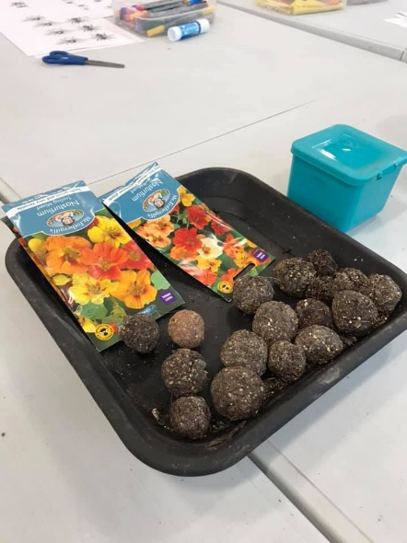 | Being able to listen to instructions  Sequencing  Appreciation of the outdoors and understanding how wildflowers attract bees to the garden  Working under own initiative  Numeracy and literacy  Improved motor sensory co-ordination  Sense of achievement and recognising own improvements  Exploring creativity (decorating pots) | A popular activity which allows Get up and Grow to talk about different wildflowers (stimulating memory), colouring in pot labels and facilitates questions and discussion about plants, wildflowers and favourite floral scents and colours.
Lavender and rose petal bags   | Being able to listen to instructions  Sequencing  Team working and communication (putting bags in gift bags and tying ribbons)  Working under own initiative  Sense of responsibility and ownership, increasing self esteem  Improved memory  Improved motor sensory co-ordination | Lavender bags are a familiar product with residents and attendees at The Willows and make a good product to sell at local fairs. | A good sensory activity that stimulated a ‘marmite’ response.  People either love or hate the smell of lavender!  However, this was a very calming activity with simple sequencing processes that most people could follow.
Indoor succulent displays and air plants  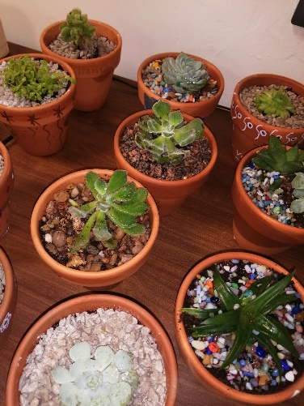  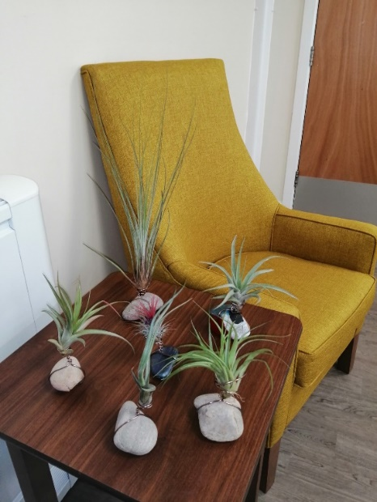 | Being able to listen to instructions  Sequencing  Working under own initiative  Sense of responsibility and ownerships, increasing self esteem  Numeracy and literacy  Improved memory  Improved motor sensory co-ordination  Sense of achievement and recognising own improvements  Exploring creativity | Good activity for using basic potting skills.  Also provides a good opportunity for self expression through the painting of pots. | A great workshop for developing confidence and a sense of satisfaction.  Attendees were left with a finished product that looked good and something that we were able to give to family members as well as selling at the local fair.
Bird feeders  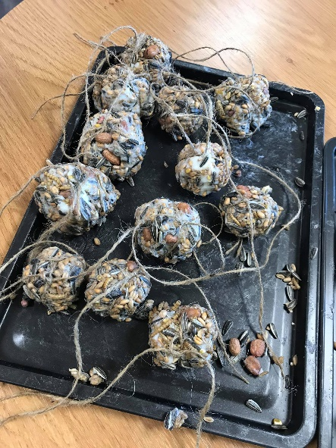 | Increased confidence – able to listen to instructions  Sequencing  Team working and communication  Appreciation of the outdoors – reminiscence therapy on wildlife and birds  Working under own initiative  Improved motor sensory co-ordination  Sense of achievement and recognising own improvements
Christmas nature-based crafts  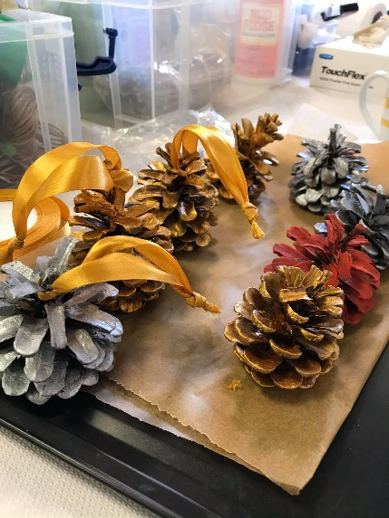 | Increased confidence, self-esteem and concentration  Being able to listen to instructions  Sequencing  Team working and communication  Exploration of using familiar items of nature in craft activities  Working under own initiative  Sense of responsibility and ownerships, increasing self esteem |  | Again a good activity for triggering memories.  One agitated client heard the Christmas music playing, sang along and this had a wonderful calming effect.  Simple painting tasks enabled all residents to join in – particularly those who still had good manual dexterity who could help with tying ribbons.
Leaf printing on fabric   | Being able to listen to instructions  Sequencing  Working under own initiative  Improved motor sensory co-ordination  Sense of achievement and recognising own improvements  Exploring creativity |  | Excellent activity that was simple and able to be completed by all attendees.  Participants seemed thrilled and fascinated with the results and enjoyed peeling off the fern leaves from the fabric to reveal intricate and unique patterns.
Botanical bath tea tubs   | Improving memory through sensory stimulation  Being able to listen to instructions  Sequencing  Team working and communication  Working under own initiative  Sense of responsibility and ownerships, increasing self esteem  Improved motor sensory co-ordination  Sense of achievement and recognising own improvements
Sedums planted in decorative teacups  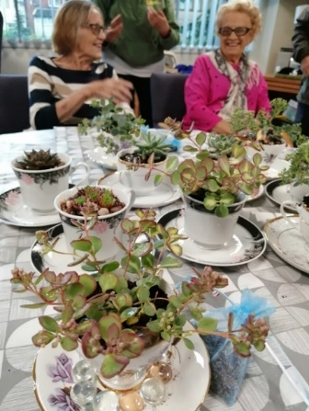 | Increased confidence, self-esteem and concentration  Being able to listen to instructions  Sequencing  Team working and communication  Working under own initiative  Improved motor sensory co-ordination  Sense of achievement and recognising own improvements
Decorating plant pots  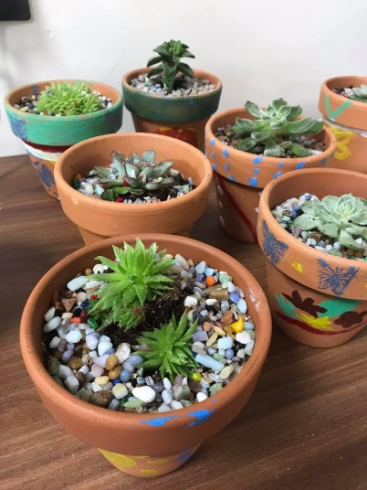 | Learning new skills and information about different plants  Being able to listen and carry out instructions  Team working and communication  Appreciation of indoor plants and how to look after them  Working under own initiative  Improved motor sensory co-ordination  Sense of achievement and recognising own improvements  Exploring creativity

Appendix II - EY – GEM Activity Monitoring (Case Study)
 | Monday | Tues | Wed | Thursday | Friday | Sat | Sunday
Get up time | 6am | 6am | 6am | 6am | 5am | 6am | 6am
Morning activity | Link for life exercise’s | GOLF | Get up and grow | Halle orchestra | Tonic Choir | Virtual Bike | Bingo
Mood during the activity | Arm chair exercise to music – enjoyed, remained engaged throughout | Went out with his carer to golf – enjoys. | Fully engaged  Happy throughout lasted 1.5 hours | Sits to watch but only for a short while, walked away  No Dancing | Likes the music  Danced for a short while  Easily distracted and walks off | Enjoys the exercise  Facial expressions are happy  Having fun  Sings to the music  Watches the screen/landscapes | Restless  No interest  Keeps walking away from the table.
Time agitation commenced | Remained engaged for the full hour  Released his ball of energy during this activity | Full day outing  Returned at 4pm  Was tired the evening  No agitation | Remained engaged  Agitation started after lunch  Another activity req | Engaged with another activity 1-1 | Friend present, went out for a walk  Returned at tea.  Tired and settled. | After all the days’ activities – settled & tired today. | Trying exits  has not engaged in the activity.  Taken out for  a walk.  More settled  On return
Trigger for agitation? | No agitation – fully engaged today. | None – fully occupied with physical activity | None – fully occupied with physical activity | Type of activity – less active/  Physical  Boredom? | Type of activity – lost interest quickly | None – fully occupied with this physical activity | The type of activity – no active enough  bored
Appetite following morning activity | Ate all his lunch- happy | Ate out - unknown | Ate all lunch with other residents  calmly | Distracted at Tea – walking away from the table | Was out for lunch – ate his tea calmly on return | Ate lunch - happy | Distracted at lunch  Didn’t eat it until 2pm.  Restless.
Sleep pattern that night | Settled 9pm  Slept well. Awake 6am for medication. | Settled 9.10pm  Slept well. | Settled night, retired at 9.15pm | Retired at 11pm, up to toilet more often than usual.  Awake at 5am. | Slept well from 9pm. | Settled night  Retired at 9.30pm | Up until midnight, restless.  declined medication on several occasions.

Appendix II - JM – GEM Activity Monitoring (Case Study)
 | Monday | Tues | Wed | Thursday | Friday | Sat | Sunday
Get up time | 4am | 5am | 4.45am | 6am | 6am | 4.45am | 6am
Morning activity | Link for life exercise’s | Giant IPAD | Get up and grow | Halle orchestra | Tonic Choir | Virtual Bike | Bingo
Mood during the activity | Music/armchair exercises Lost concentration after 10 mins. | Watched a comedy  And a word search | Liked the small craft activity’s – made lavender bags today – kept concentration throughout | Enjoyed the music, facial expression is happy  Liked the Irish fiddle. | Didn’t engage  Wanted to go outside for a cigarette throughout  Bored. | Enjoys the exercise  Facial expressions are happy  Having fun  Sings to the music  Watches the screen/landscapes | Loves Bingo – sat throughout  The game all afternoon
Time agitation commenced | 10 mins after leaving the activity.  Didn’t prevent restlessness | Working on the large screen relaxed J  More Settled today | Remained engaged  Had a rest in the afternoon- settled | More settled this evening. | Agitated most of today, restless and irritable. | After lunch remained settled, rested for periods. | Was tired at tea, settled  this evening watching Bernard manning on Ipad.
Trigger for agitation? | Restless all day – bored? | None – fully occupied with physical activity | None – fully occupied with physical activity | Type of activity – less active/  Physical  Boredom? | Type of activity – lost interest quickly | None – fully occupied with this physical activity | Happy this evening
Appetite following morning activity | Only ate small amount  Loosing concentration at the table | ate lunch today | Tired at lunch- didn’t eat much | Tired at tea but ate small amount. | Declined to sit at table for lunch, ate small amount in armchair | ate lunch calm | Tired and calm,  ate small tea on knee.
Sleep pattern that night | Restless till 11pm.  Up x 5 in the night. | Asking to go to bed from 7pm not settled till 11pm.  Up early at 4.45am | Retired at 11pm – up x 3 toilet, time. | Asking to go to bed from 7pm but not settled till 12am mostly restless all night 1-1 | Asking to go to bed from 6pm but no settled, went to bed 9pm, restless night 1-1 | Settled fairly well from 12pm, up x 2 toilet | Retired at 11pm. Settled fairly quickly. Up x 4.  Rose 6am.

